**Week 3 Profile**

Results:  
The accelerometer and the magnetometer data is getting logged into the SD card in the CSV format.

Difficulties:  
I had failed to initialize the f3d_delay_init(). Due to this the program was only giving me one output each of accelerometer and magnetometer data and then going into perpetual delay. The error was discovered by GDB debugging. While writing the data into the SD card. The data was not getting written into the file since there was an issue with the name of the file. Once the name of the file was changed the data was logged successfully.

Plans for this week:  
To log the data from the receiver into the SD and store it in CSV format. Once that is done testing of the Step Counter using the battery supply can be started.

Block Diagram

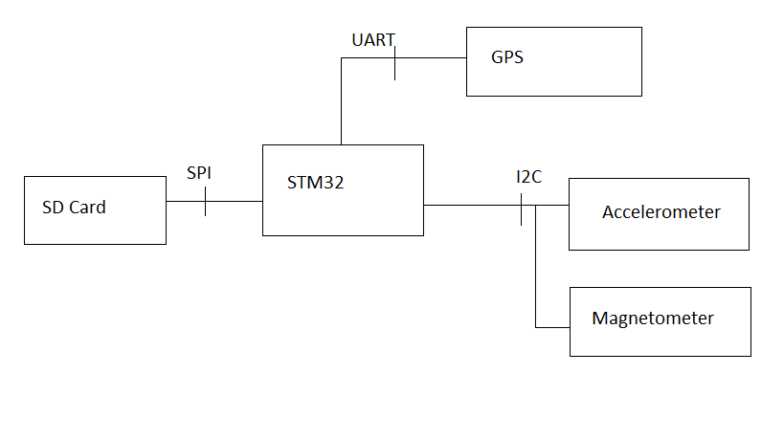

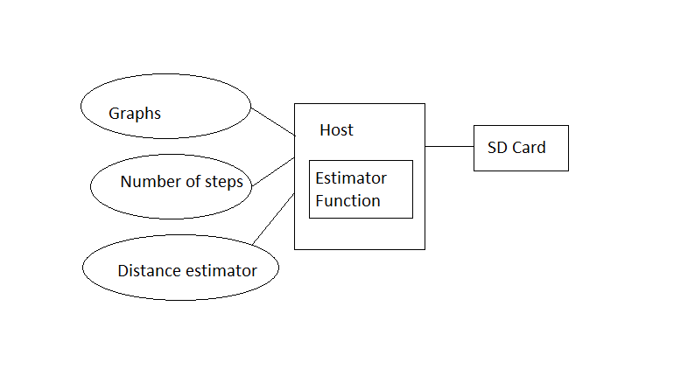

|  |  |  |  |
| --- | --- | --- | --- |
| Category | Design Objective | Deliverable | Status |
| Power | Battery Life | The battery can last for months depending upon the frequency with which it is used. |  |
| Power | Battery Availability | The system can work on commercially available 9V battery. |  |
| User Interface | Web Access | Web application should be in place to enable the user to visualize the data. | Started |
| Data Logging | Information Storage | The SD card can log in a large number of data entries. | Completed for magnetometer and accelerometer data (GPS pending) |
| Mechanical | Environmental | The system should work fine in the temperature range of -30 C to 70 C. |  |

Project Schedule

